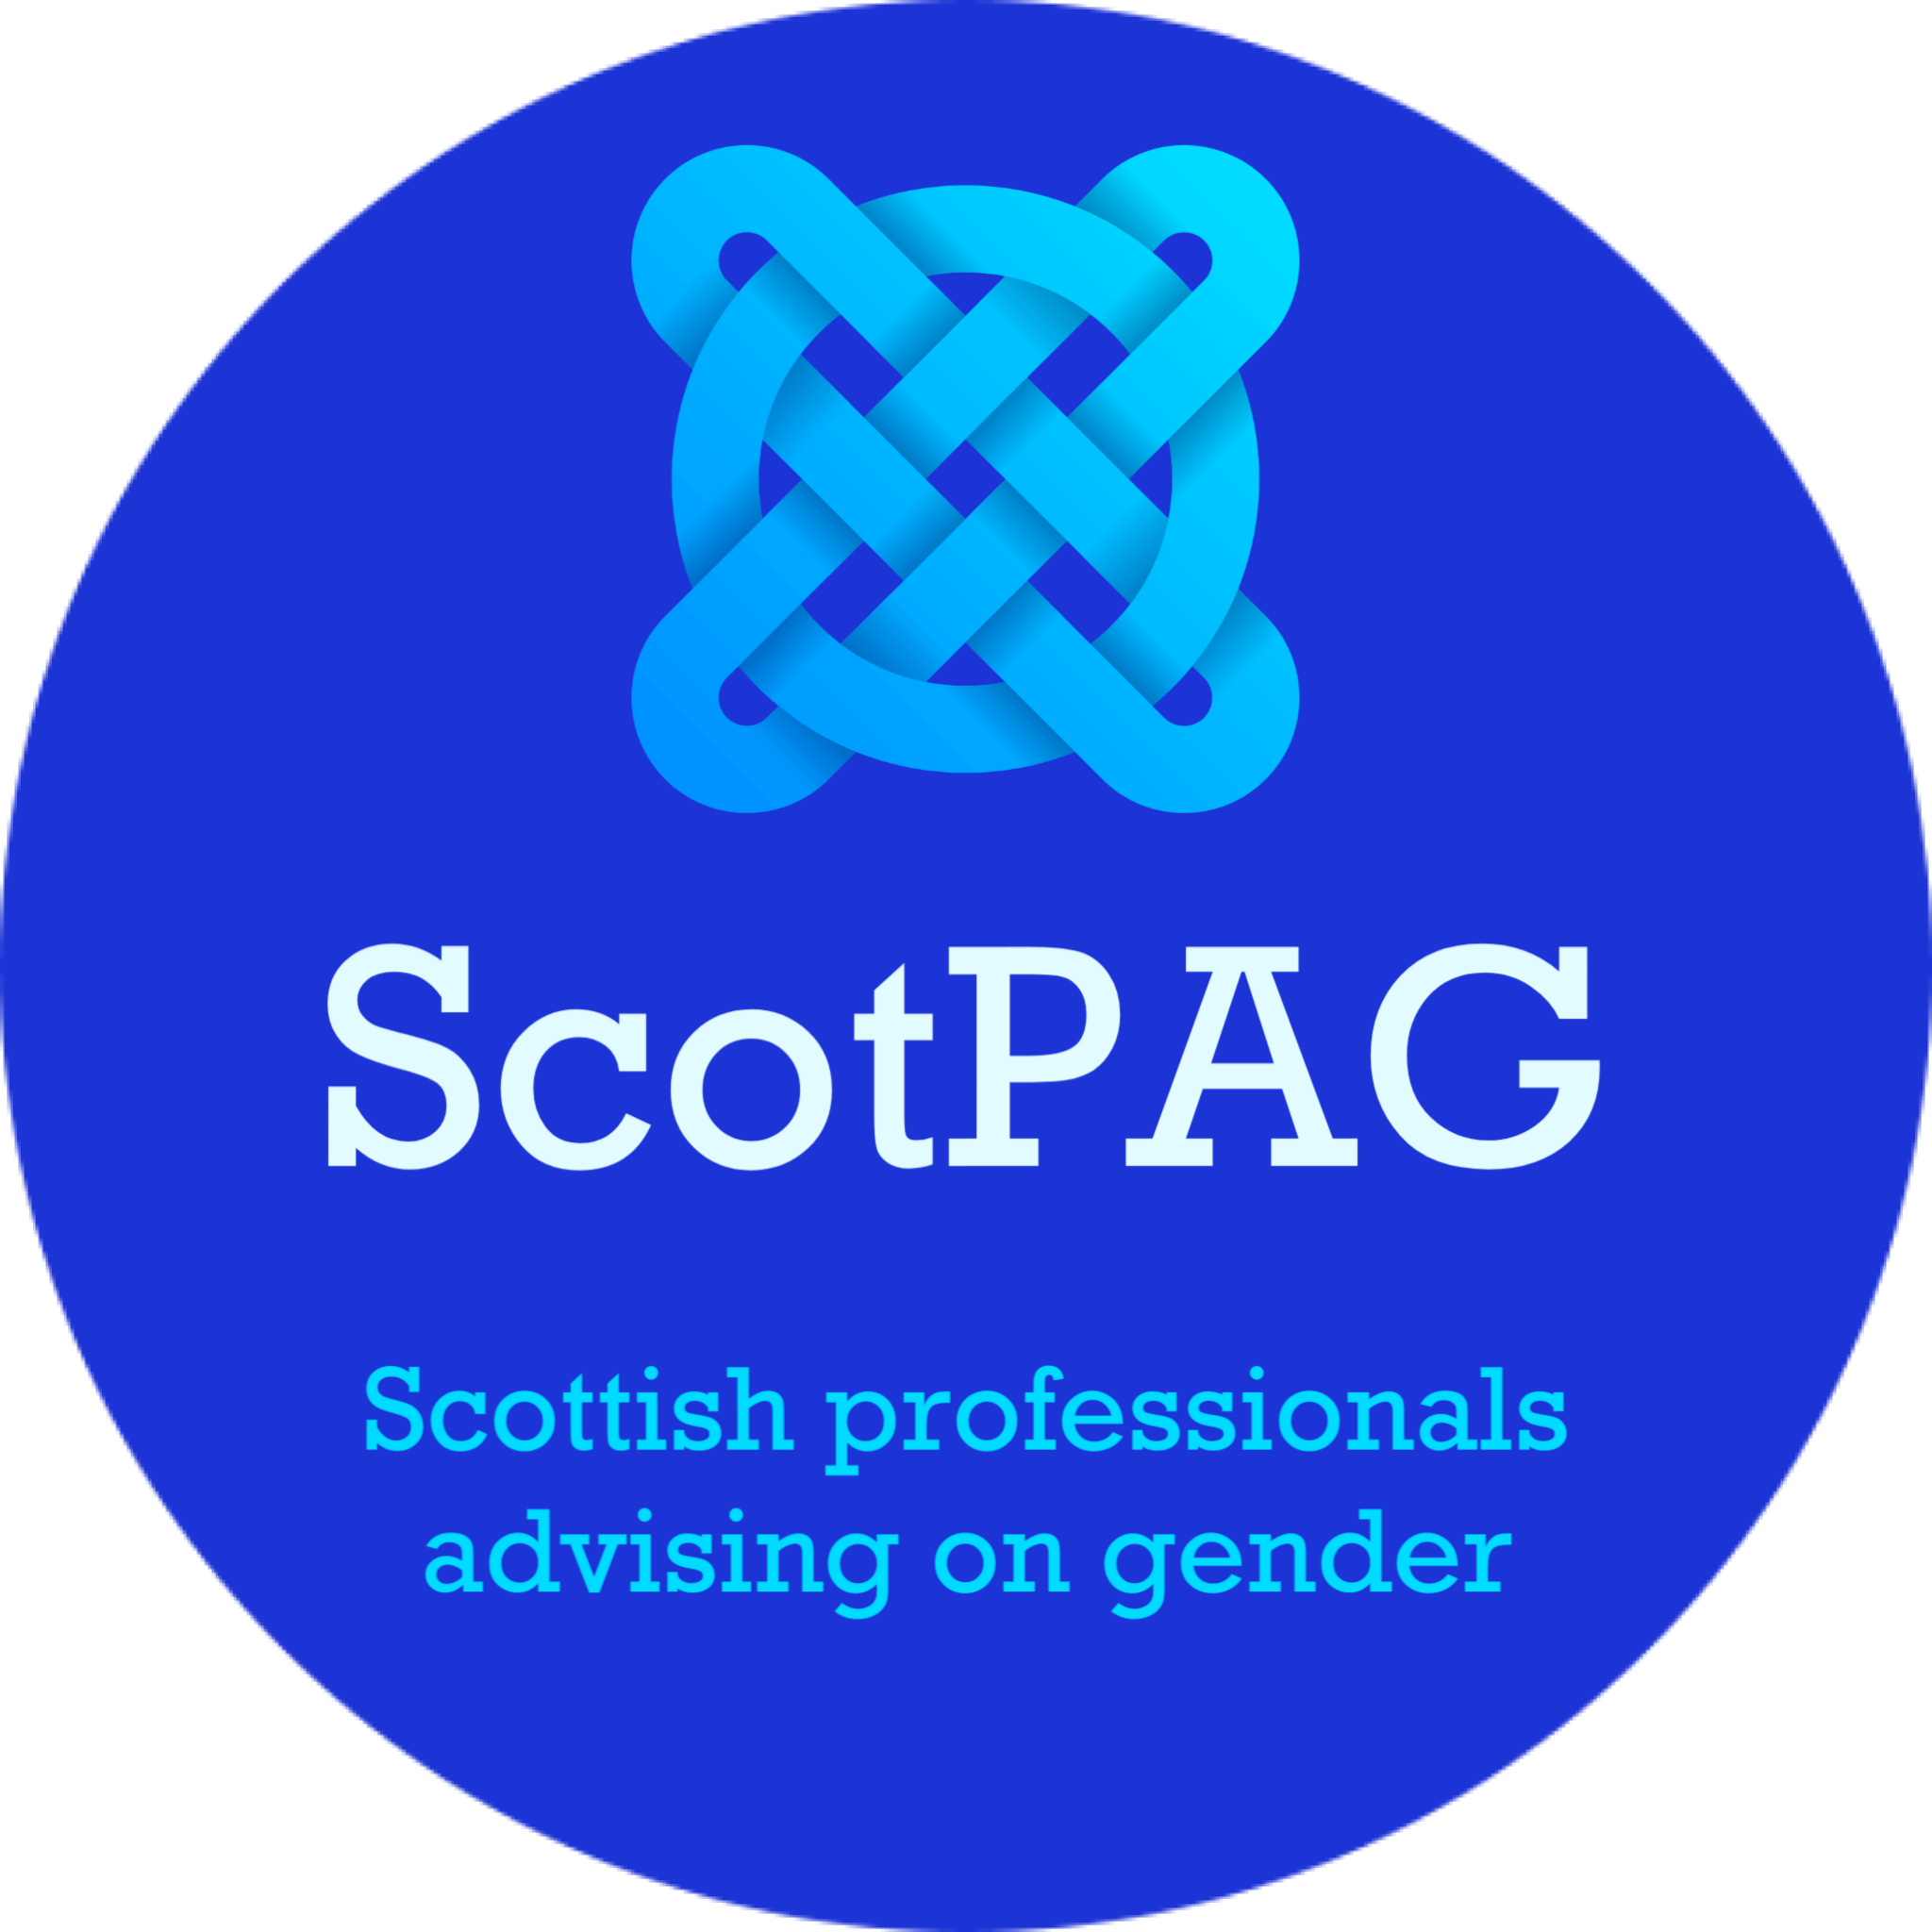

15 September 2024

To Jenny Minto MSP
Scottish Parliament

Dear Ms Minto
I am writing on behalf of an organisation called Scottish Professionals Advising on Gender (ScotPAG). We are a group of health, education and social work professionals who are concerned about the direction Scotland is taking with regard to supporting and caring for children and young adults who state that they are transgender.
I am writing regarding your statement to Parliament September 3rd 2024, regarding the issue of gender ideology being taught in schools. You stated: ’Children and young people are not taught about their own gender ideology in schools.’
This cannot, by any stretch of the imagination, be described as accurate. You will be aware of the 2024 Cass Report’s findings based on systematic, international research and that Dr Cass has confirmed the following:
- Gender ideology is an unconfirmed pseudoscience
- The promotion and ‘product placement’ of gender ideology in schools can be psychologically harmful for children
- The promotion of the idea that any individual can change sex is confusing and has the potential to make any child anxious
- Research reports that breast binding is physically harmful for the majority of girls
- Social transitioning and affirmation is not helpful for any child as it reinforces a delusion and inevitably means that other children have to collude with this and so can suffer confusion and mental health issues because they are being asked to agree with something untrue.

The Scottish Government’s schools guidance, Supporting transgender pupils in schools promotes gender ideology in schools by doing the following:
- stating that children can become the opposite sex
- using terminology such as ‘assigned at birth’ (gender ideological terminology)
- uses the ‘product placement’ of the term ‘trans’ for children when there is strong evidence that ‘trans’ does not apply to children confused about their sexuality as the term is vague, ill-defined and is a rebrand of adult male fetishes
- promotes social transitioning and affirmation as a positive approach when there is clear evidence it is harmful to children as it sets them on a specific path towards potential further confusion and medicalization.
The Scottish Government Relationships, Sexual Health and Parenthood (RSHP) provides curricular materials and lesson plans, specific sections of which, follow the above outlined gender ideological approach. There are gender ideological statements throughout such as ‘assigned at birth’, ‘some boys will become girls’, whole sections on children who are ‘trans’ (in the primary levels) while in the adjacent sections there is no mention of children being gay. Social transitioning and affirmation are treated as a positive option in certain lesson plans. These examples are all consistent with a gender ideological approach. It should be remembered that there is no evidence that supports gender ideology; it is a belief system that has no basis in fact. It should certainly not be being taught in our schools as if it were fact and yet that is exactly what the Scottish Government is doing by presiding over guidance and curricular materials which promote gender ideology in all its various forms. This approach being pushed by the Scottish Government is creating significant safeguarding issues. (Our addendum to this letter shows examples of gender ideology being taught in schools).
Clearly schools should have a preventive role in safeguarding children. Schools should have a preventive role in ensuring children’s emotional wellbeing and mental health, and parents should not have to worry about their children being indoctrinated by a pseudoscientific ideology. ScotPAG is aware of many parents who have had a stressful and challenging time managing a teenage son or daughter who has announced that they are ‘trans’ due to being influenced by the messages he or she has received in school.
Fergus Ewing has stated, ‘I’ve been inundated with comments from people with clear examples that this is being taught in schools, I’m therefore now writing to the minister to ask that she withdraw this false statement, correct the record and apologise.’
We agree with Mr Ewing. We are aware of many situations where children and their families have been affected by schools having embedded gender ideology not only in their curriculum but in many aspects of school life including school assemblies; toilets being made gender neutral; changing rooms being shared by girls and boys; staff training; and whole school planning. There is no doubt that gender ideology is not only being taught in schools, it is being actively promoted while fact based alternatives are being repeatedly avoided.
Our view is that Ms Minto’s statement was not only inaccurate, it was flying in the face of significant evidence to the contrary. We agree with Mr Ewing that Ms Minto’s statement should be withdrawn with immediate effect and a statement of apology made.
Yours sincerely

Carolyn Brown (Convenor of ScotPAG)
e-mail: info@scotpag.com Web: scotpag.com

CC Mr Fergus Ewing MSP

