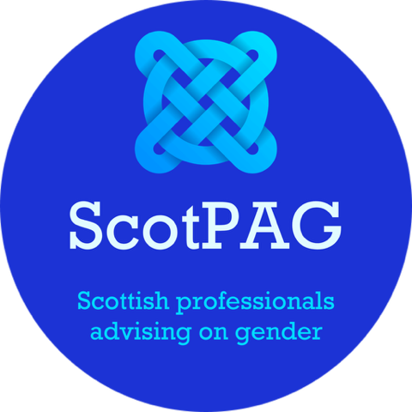
8th July 2025

To:
Jenny Gilruth MSP, Minister for Education and Skills
Tom Arthur MSP, Minister for Social Care and Mental Wellbeing
Neil Gray MSP, Cabinet Secretary for Health and Social Care
Joe Griffin, Permanent Secretary, Scottish Government

Dear Ministers Gilruth, Arthur, Gray and Permanent Secretary Griffin,

Subject: Following Supreme Court Ruling and EHRC Advice,
Urgent Withdrawal of Unlawful Trans Guidance for Schools and Care Inspectorate Guidance for Trans Children

We are: Scottish Professionals Advising on Gender otherwise known as ScotPAG. ScotPAG is a group of professionals from education, social work and health who have concerns about how the terms ‘gender identity’ and ‘transgender’ are understood. We are writing to you in order to express our serious concerns regarding the continued use of the Scottish Government’s transgender guidance for schools and pupils and the Care Inspectorate’s transgender guidance for children and young people. Following the UK Supreme Court’s unanimous ruling on 16th April 2025 in For Women Scotland Ltd v The Scottish Ministers [2025] UKSC 16, and the subsequent interim guidance issued by the Equality and Human Rights Commission (EHRC), it is clear that these guidance documents are unlawful and pose significant risks to the safeguarding of children in Scotland. We urgently call for their immediate withdrawal.

The Supreme Court’s ruling clarified that the terms ‘sex,’ ‘man,’ and ‘woman’ in the Equality Act 2010 refer to biological sex, not gender identity or certificated sex as modified by a Gender Recognition Certificate (GRC). This decision has profound implications for policies and guidance that rely on definitions of sex or gender that deviate from biological reality. The EHRC’s interim guidance, issued in May 2025, further reinforces that public bodies, including schools and care services, must align their policies with this legal definition of sex to comply with the Equality Act 2010. It explicitly states that duty-bearers should not wait for the updated Code of Practice to review and amend their policies to ensure compliance with the law as settled by the Supreme Court.

The Scottish Government’s transgender guidance for schools, which permits practices such as allowing pupils to access facilities and participate in activities based on self-identified gender rather than biological sex, is now clearly incompatible with the Supreme Court’s ruling. Similarly, the Care Inspectorate’s transgender guidance for children and young people, which advises care providers to treat children according to their gender identity, undermines the legal protections afforded to biological sex-based rights and risks compromising the safety, privacy, and dignity of children in care settings. These guidance documents directly contradict the EHRC’s advice that single-sex services and spaces, such as toilets and changing facilities, must be based on biological sex to remain lawful.

Moreover, we are deeply troubled by reports that the Scottish Government has misrepresented the EHRC’s advice. The EHRC, through Baroness Kishwer Falkner, has explicitly stated that it did not advise ministers to delay action until the final Code of Practice is published. Instead, it has emphasized that public bodies must act immediately to ensure compliance with the law. The Scottish Government’s delay in withdrawing or revising these guidance documents risks perpetuating unlawful practices and exposing vulnerable children to harm, particularly in settings where safeguarding is paramount.

The continued enforcement of these guidance documents not only contravenes the Supreme Court’s ruling but also undermines the trust of parents, guardians, and the wider public in the Scottish Government’s commitment to upholding the law and protecting children. The failure to act promptly could lead to further legal challenges, as highlighted by For Women Scotland, who have expressed frustration at the Scottish Government’s inaction and suggested that additional litigation may be necessary.

We therefore urge you to:

- Immediately withdraw the transgender guidance for schools and the Care Inspectorate’s transgender guidance for children, as both are unlawful in light of the Supreme Court’s ruling and EHRC advice.

- Issue interim guidance to all schools and care providers in Scotland, clarifying that policies and practices must align with the biological definition of sex as mandated by the Equality Act 2010.

- Engage urgently with the EHRC to ensure that all relevant policies are updated to reflect the legal clarity provided by the Supreme Court and to safeguard the rights, safety, and wellbeing of all children.

The protection of children’s safety and rights must be paramount. The current guidance, by prioritising gender identity over biological sex, risks undermining the privacy, dignity, and safeguarding of children, particularly in single-sex spaces. We call on you to act swiftly to rectify this situation and to demonstrate the Scottish Government’s commitment to upholding the law and protecting Scotland’s children.

We would welcome the opportunity to discuss this matter further and request a response within 14 days outlining the actions the Scottish Government will take to address these concerns.

Yours sincerely,

Carolyn Brown
Retired Depute Principal Educational Psychologist and Convenor of ScotPAG
cbrown303@btinternet.com

Additional signatories
Prof Brigid Daniel, Retired Professor of Social Work
Maggie Mellon, Social Worker, MSc, CQSW, Dip Child Protection
Dr Anne Woodhouse, Clinical Psychologist
Carole McKenzie, Retired Director of Education
June Campbell Retired Psychoanalytic Psychotherapist
Pauline Fox, Retired Clinical Nurse Specialist, RMN NMP

cc:
Shirley-Anne Somerville MSP, Cabinet Secretary for Social Justice

Baroness Kishwer Falkner, Chair, Equality and Human Rights Commission

For Women Scotland info@forwomen.scot

