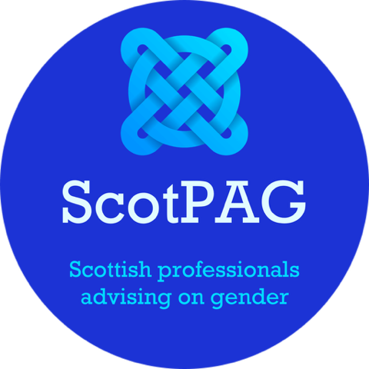

Date: 14th April 2025
Subject: Concerns Regarding the Royal Zoological Scotland Society Leadership’s Intentions to Sign Up to the LGBT Youth Scotland Charter
To:
David Field Chief Executive Officer
Ben Supple Depute Chief Executive Officer
Dear Sirs,
I am writing to you on behalf of ScotPAG, a non-profit organisation. We are a group of professionals from education, social work and health with major concerns regarding the promotion of gender ideology across public services and other organisations. Our aim is to define best practice for children, young people and adults affected by the proliferation and promotion of gender ideology. We also aim to support professionals in their workplace who have concerns about the ongoing negative influences of gender ideology.
From your website, we have recently become aware of a post dated 28th February which states that the RZSS is signing up to the LGBTYS Charter. I write to make you aware that ScotPAG has significant concerns about this decision, and I urge you to carefully consider the implications before you proceed.
Below, I outline ScotPAG’s concerns
- Lack of Transparency and Accountability in LGBTYS Operations: LGBTYS, while positioned as a charity supporting LGBTQI+ youth, has faced scrutiny and investigations by the Office of the Scottish Charity Regulator (OSCR) due to regulatory concerns. These include concerns about the employment of some staff who have been involved in recent serious criminal activities including the corruption of young people.
- LGBTYS promotes gender ideology, an unevidenced and unproven concept which tells children that they can change sex and encourages children in schools to socially transition if they see fit. As a retired psychologist with many years experience, I must warn you that the promotion of gender ideology is harmful psychologically to children, partly because it is proposing to children that they should engage in delusional thinking and it has the potential to facilitate children to think that there is something wrong with their perfectly healthy bodies.
- LGBTYS has publicly stated that it disagrees with the Cass Review. Dr Cass is a highly esteemed medical practitioner who carried out the most extensive research to date about gender identity and medical treatments. She has warned about the poor standard of research regarding various aspects of ‘gender affirming care’, to which LGBTYS is highly supportive and promotes in schools and youth groups.
- LGBTYS has been linked to past scandals, including historical abuse allegations and associations with individuals convicted of serious crimes, such as James Rennie, a former chief executive. This raises serious questions about the organization’s credibility and suitability as a partner for an institution like the RZSS including Edinburgh Zoo, which holds a public trust in animal welfare, community engagement and is visited by many children and families.
- ScotPAG’s view is that LGBTYS has extended its influence into educational and youth settings, including schools, where it promotes materials and ideologies that lack balance or scientific grounding. As I mentioned above, it advocates for children to socially transition and it encourages children to do so against the wishes of parents. It encourages the use of breast binders despite clear evidence that this is harmful to girls’ developing bodies. LGBTYS has encouraged young children as young as 10 to engage in lobbying efforts regarding transgenderism, such as writing to politicians about gender-neutral facilities. For RZSS to align with an organization that has been criticized repeatedly for such practices could undermine public trust and divert focus from your core mission of animal conservation, inclusion of all children and families and their welfare.
- Potential Misalignment with RZSS Objectives:
I presume that RZSS’s primary role is to advance scientific approaches, animal welfare, conservation, education and public engagement. Signing up to the LGBTYS charter, which focuses on ideological issues, may distract from these goals and confuse stakeholders about your priorities. The Scottish Animal Welfare Commission and other bodies emphasize the importance of scientific and ethical standards and I fear that association with an organization under scrutiny could damage your reputation and dilute your focus on these critical areas.
- Public Funding and Ethical Concerns:
LGBTYS receives significant public funding from the Scottish Government and other sources, yet it continues to face criticism for promoting policies and practices that many experts, including ScotPAG view as harmful and based on no scientific evidence. LGBTYS stated that they viewed puberty blockers as “wonderful”. This statement is simply not true. The Cass Report has categorically found there to be no evidence that puberty blockers improve children’s mental health and there is solid evidence that they are harmful to children. On behalf of my ScotPAG colleagues I would advise RZSS that partnering with an organization with LGBTYS is likely to damage RZSS’s reputation and public standing.

On behalf of ScotPAG, I respectfully suggest that RZSS reconsider its intentions to sign up to the LGBTYS charter. I urge you to conduct a thorough review of LGBTYS’s track record, current controversies, and the potential impact on your institution’s mission and public perception. RZSS has an important role to play in Scottish society, and ScotPAG is committed to supporting initiatives that uphold integrity, transparency, and evidence-based decision-making. I look forward to your response and hope you will take ScotPAG’s concerns into serious consideration.
Yours sincerely,

Carolyn Brown ScotPAG Convenor
cbrown303@btinternet.com
(retired depute principal educational psychologist)

scotpag.com
@scotpag

